NEWS PRESS RELEASE
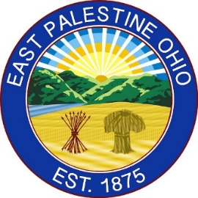
CONTACT INFORMATION:

Village of East Palestine
Office of the Village Manager
(330) 426-4367
m.mctrustry@eastpalestine-oh.gov

FOR IMMEDIATE RELEASE

Headline: Ribbon cutting ceremony for disc-golf course official opening

Celebrating the people that have invested in the community of East Palestine.

[East Palestine, Ohio, June 3rd, 2022] –

Press release: “Ribbon cutting ceremony for disc-golf course official opening”
Date of Release: Friday June 3rd, 2022
Released via: Press release email list only

In late 2019, the East Palestine Park Board intensified their efforts to raise funds to provide another recreational resource for the City Park. Through their hard work and dedication, they were able to connect with the East Palestine Community Foundation and the East Palestine Masonic Temple who donated the needed funds to the Park Board, so that the equipment could be purchased. The East Palestine Eagles donated additional funds to help with the costs of installation, signage, and other required elements.

Throughout 2020 and into 2021, the Park Board and the Village Manager worked with a course architect to make the course as fun and as challenging as possible for users: the goal of the course was to provide a competition level course for residents and users from other communities, as well as a course that would be enjoyable for new users.

Upon installation, the course got regular use: there have been as many as one-hundred-players using the course, in a single day: the course has become a draw for people far and wide to come to the park – there were many faithful users of the course on even the snowiest of Winter days.

Due to the hard work, tireless efforts, and generosity of community minded people the Village Administration believe that this success that should be celebrated and promoted. For the official ribbon cutting members of the supporting organizations, Park Board members, and Village Council members have been invited participate in a brief ceremony. The ceremony will be held at the Don Smith & Veterans Memorial Gazebo, East Palestine City Park, 31 Park Ave., East Palestine, OH on Saturday, June 11th 2022, 11:00am.

The Village of East Palestine Park Board is responsible for advising the Village Manager on the acquisition, development, maintenance and operation of the parks and recreational facilities of the Village.
####

East Palestine is a village in eastern Columbiana County, Ohio, United States, and was incorporated in 1875. The population was 4,761 at the 2020 census. East Palestine is ‘The Place You Want to Be” and is Bulldog Proud

